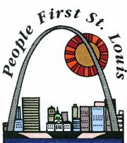
Running a Productive Meeting
How We Do It
- Turn-Out: Phone Calls and Reminder letters
  - Officers and Members do this.
  - Makes sure we are all there and on time.
- Planning Meeting: Pick Topics, Make Agenda, Assign Roles to Officers.
  - Officers do this.
  - Helps make sure we learn new stuff.
- Pre-Meeting: Run through the meeting and remind each other of our roles and what we want to say.
  - Officers and Advisor
  - Helps make sure we are prepared.
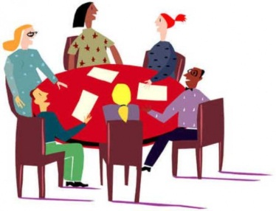
- The Meeting: Where we plan out our community work or other activities, take action, and get updates!
  - Officers and Members
  - Allows us to plan and get involved in action.
  - Need to agree on rules during meeting and follow them.
- Evaluation: Go over what happened at the last meeting. What was good and what was bad at the last meeting.
  - Officers and Advisor
  - Officers and Members
  - Helps us make sure we are always getting better.

Leaders Do the Work
The officers help keep everything in line and going forward
Example of in meeting tasks completed by officers in St. Louis.
- President: Makes sure that the meeting is moving along.
- Vice President: Will Step in for the president or others when there is a role not being filled. Also, will often present on topics.
- Secretary: Makes sure sign-in happens, takes notes, and ensures handouts get to people.
- Sergeant at Arms: Makes sure people are calm, respectful, keep phones off, and makes sure everyone gets back to the meeting after break.
- Treasurer: Keeps track of People First Funds and leads the Fundraising committee.
- Steering Committee: Represents People First of St. Louis at the People First of Missouri Steering Committee and will give regular reports on it. Additionally will help fill in gaps when needed.

